Scenario 9: How to extend CPU and RAM for an instance.
We have an instance running with 1 GB RAM and 2 core CPU.
Step 1: to identify the right instance type with cost efficient
Currently our server is running t3. micro with 2 vCPUs and 1 GB RAM.
Let’s select cost efficient option, we need 2vCPUs with 2 GB RAM,
Let’s go for t3.small
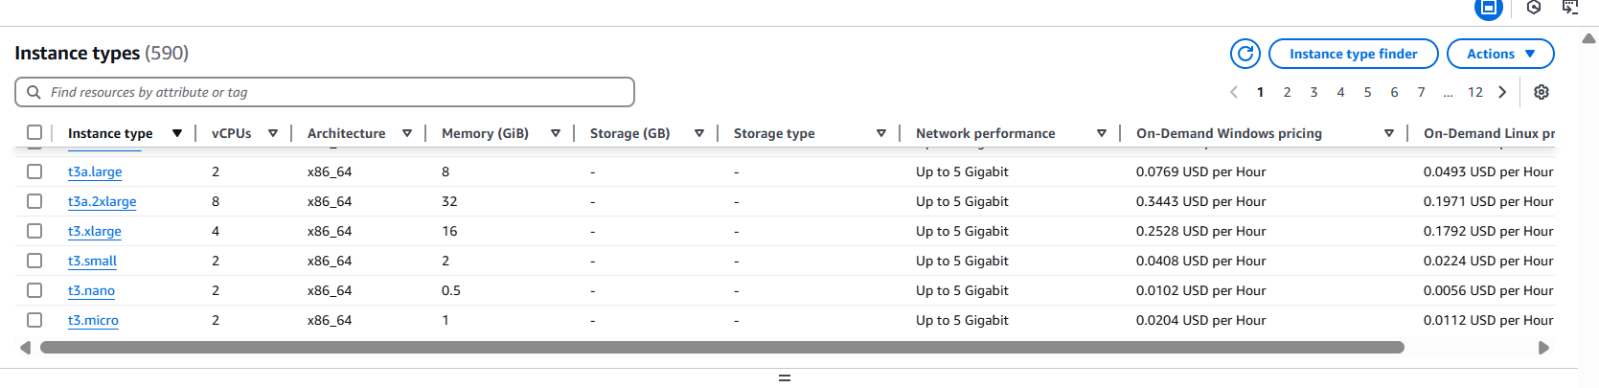
Step 1: Let’s extend it, before that we need to power the server.
Select the VM > actions > change instance types
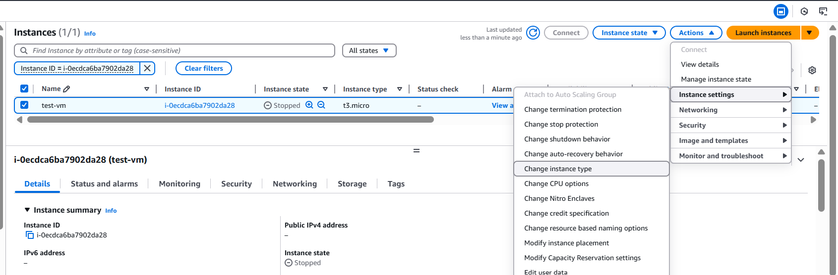

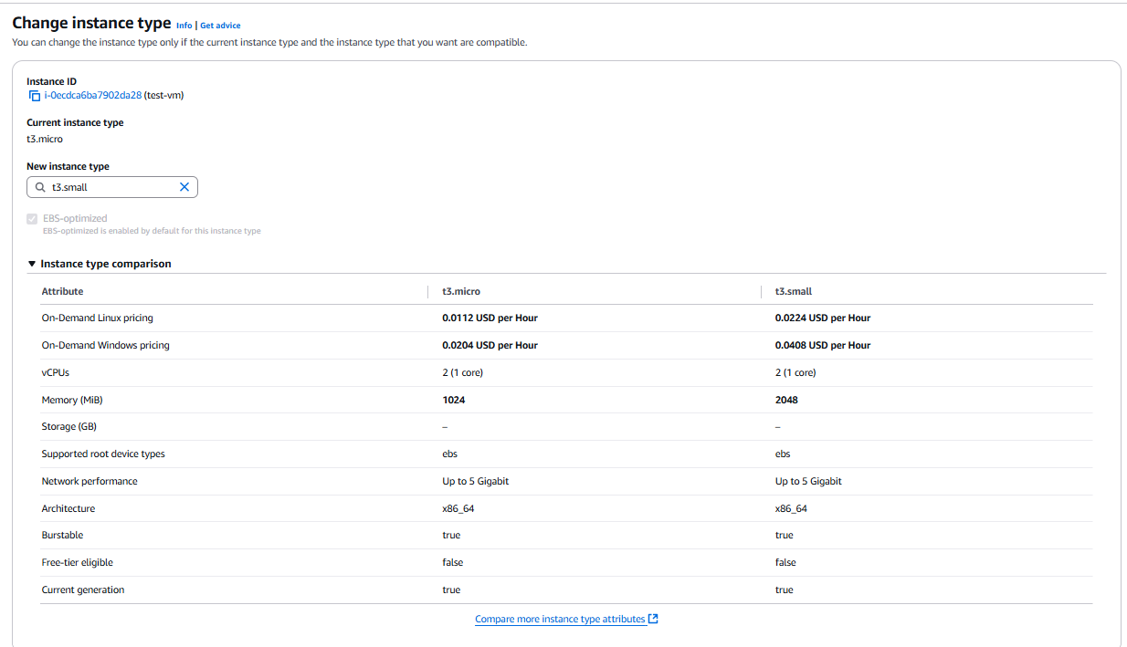
Click on change
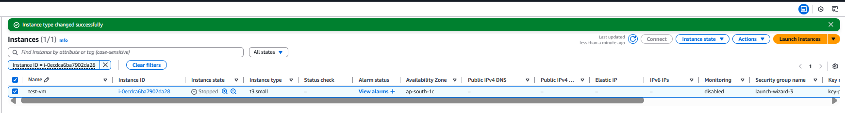

Step 4: lets validate by logging in to the server.
